12.53: a) From Eq. (12.14),
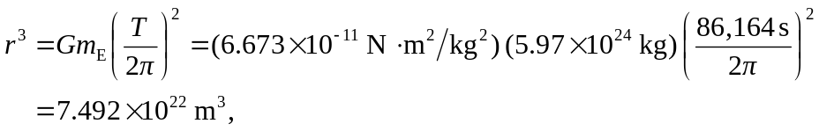
and so 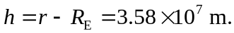 Note that the period to use for the earth’s rotation is the siderial day, not the solar day (see Section 12.7). b) For these observers, the satellite is below the horizon.

